Name: _______________________________________________ Period: _________ Teacher: Mrs. Macedo

Unit 9: Carbon Cycle & Climate Change

## Learning Targets

Learning Targets are broken into success criteria—these are the individual skills you must demonstrate to show mastery of each learning target. They are shown as the bullets underneath the learning target. The general rubric below will be used with each of the learning targets:

**Rubric for all Learning Targets**

|  |  |  |  |  |
| --- | --- | --- | --- | --- |
| **0**  **No Evidence** | **5**  **Not Yet** | **7**  **Approaching** | **8.5**  **Proficient** | **9 - 10**  **Advanced** |
| Left 2 or more questions blank on the assessment | No evidence of proficiency with the learning target but attempted the questions. | Shows beginning proficiency with the learning target, but is inconsistent or makes several errors (>4 errors) | Demonstrates understanding of most or all of the learning target, but misses no more than 1 success criteria or makes 3-4 errors | Demonstrates mastery of learning target; makes no more than  1-2 minor errors |

**LT 9.1 Human activities influence the carbon cycle.**

* I can categorize examples of weather vs. climate.
* I can identify local and global biological, extreme weather, ocean, and cryosphere changes occurring as a result of climate change

**LT 9.2 Human activities increase the amount of greenhouse gases in the atmosphere which threaten the environment and human health.**

* I can explain the greenhouse effect – how energy from the sun is trapped by greenhouse gases (GHG’s) in the atmosphere to heat earth.
* I can analyze graphical scientific data to determine a relationship between carbon dioxide and temperature

**LT 9.3 Changes can be made to individual and global lifestyles to decrease carbon footprints.**

* I can define carbon footprint.
* I can identify and explain individual changes I can make to reduce my carbon footprint.
* I can identify and describe technologies developed to locally and globally reduce carbon footprints

**Student Instructions:**

1. Activity 1: Read about the difference between weather and climate on page 2 **and** complete the “Weather vs Climate” practice worksheet on page 3.
2. Activity 2: Use the NASA website OR the information on pages 5 to 7 to complete the “Climate Change: How do we know?” worksheet on page 4.
3. Activity 3: Read the climate refugee article on pages 8-10. As you read the article, answer the questions at the top of page 8. Lastly, answer the questions at the bottom of page 10.

**Completed packets are due back to the school’s front office no later than Monday, 4/13!**

**Activity 1: Weather vs. Climate**

**What is the difference between weather and climate?**

**[Weather](https://nsidc.org/cgi-bin/words/word.pl?weather" \o "Glossary)** is the day-to-day state of the atmosphere, and its short-term variation in minutes to weeks. People generally think of weather as the combination of temperature, humidity, precipitation, cloudiness, visibility, and wind. We talk about changes in weather in terms of the near future: "How hot is it right now?" "What will it be like today?" and "Will we get a snowstorm this week?"

[**Climate**](https://nsidc.org/cgi-bin/words/word.pl?climate) is the weather of a place averaged over a period of time, often 30 years. Climate information includes the statistical weather information that tells us about the normal weather, as well as the range of weather extremes for a location.

We talk about climate change in terms of years, decades, centuries, even millions of years. Scientists study climate to look for trends or cycles of variability, such as the changes in wind patterns, ocean surface temperatures and precipitation over the equatorial Pacific that result in El Niño and La Niña, and also to place cycles or other phenomena into the bigger picture of possible longer term or more permanent climate changes.

**Forecasting Weather and Predicting Climate**

Weather forecasters try to answer questions like: What will the temperature be tomorrow? Will it rain? How much rain will we have? Will there be thunderstorms? Today, most weather forecasts are based on numerical models, which incorporate observations of air pressure, temperature, humidity and winds to produce the best estimate of current and future conditions in the atmosphere. A weather forecaster then looks at the model output to figure out the most likely scenario. The accuracy of weather forecasts depends on both the model and on the forecaster's skill. Short-term weather forecasts are accurate for up to a week. Long-term forecasts, for example seasonal forecasts, tend to use statistical relationships between large-scale climate signals such as El Niño and La Niña and precipitation and temperature to predict what the weather will be like in one to six months time.

Forecasts — whether generated by artificial intelligence, meteorologists, or indigenous elders — often rely on past weather patterns to predict the future, but climate change is making the past a less effective predictor of the future.

Climate predictions take a much longer-term view.  These predictions try to answer questions like how much warmer will the Earth be 50 to 100 years from now? How much more precipitation will there be? How much will sea level rise? Climate predictions are made using global climate models. Unlike weather forecast models, climate models cannot use observations because there are no observations in the future.

Adapted from: <https://nsidc.org/cryosphere/arctic-meteorology/climate_vs_weather.html>

Name: ______________________________________ Period: _________ Teacher: ______________________

**Weather Versus Climate Practice**

Define Weather in your own words –

Define Climate in your own words –

☞Read the statements. Decide if they are about weather (W) or Climate (C).

1. ____The temperatures in Brentwood have been unusually warm for February this year.

2. ____Seattle, Washington gets 38 inches of rain, on average, every year.

3. ____The average temperature in Antarctica is -70.6°F.

4. ____A snow-advisory was issued for Bear Valley, in Lake Tahoe.

5. ____ The last few years, as we’ve been having warmer Springs, I’ve noticed the swallows returning earlier and earlier.

6. ____Fresno gets smoggy when the temperatures are hot.

7. ____The number of tornadoes in Kansas have been increasing for the last 20 years.

8. ____The wind speed is only 14 mph in Chicago today!

9. ____ Over the last 10 years, Chamonix, Mont Blanc ski resort in the alps has gotten more and more snow every year.

10. ____ As Belinda got off the plane in Florida, she felt the wet warm humid air immediately.

11. ____ People love living in California because it doesn’t get too hot.

12. ____Robert’s baseball game was postponed because of rain on Saturday.

**Activity 2: Climate Change: How do we know?**

**If you do not have internet access, the website pages are included in the packet on pages 5-7!**

☞ Go to this website: <https://climate.nasa.gov/evidence/>

☞Click on ‘Evidence’ Tab.

☞ Complete the following sentences to describe the evidence for climate change.

1. **Carbon Dioxide levels in our atmosphere:**

Every 100,00 years or so (for the past 800,000 years) the carbon dioxide levels have ______________________________________________________________________________.

However, in the last 50 years, carbon dioxide levels have____________________________________.

2**. Global Temperature rise:**

Since the 1900’s (the start of the industrial revolution), carbon dioxide levels have increased and the global temperature has _______________________________________________________________.

3. **Warming Oceans:**

The increased global temperatures over the last century have caused ocean temperatures to________________________________________________________________________________.

4. **Shrinking Ice Sheets**:

In the last 30 years, the Greenland and Antarctic ice sheets (which hold much of the world’s fresh water) have______________________________________________________________________________.

5. **Glacial Retreat:**

Glaciers around the world are _________________________________________________________.

6. **Decreased Snow Cover**:

In the Northern Hemisphere, over the last 50 years, snow cover has changed by __________________________________________________________________________________.

7**. Sea Level Rise**:

In the last 100 years, global sea levels have changed by __________________________________________________________________________________.

In the last 20 years, global sea level change has ____________________________________________.

8. **Declining Arctic Sea Ice**:

Over the last few decades, the area and thickness of arctic sea ice has __________________________.

9. **Extreme Events:**

Over the last 70 years, the number of years with record high temperatures have __________________ while the number of years with record low temperatures have ________________________________.

During these last 70 years, the number of intense rainstorms have _____________________________.

10. **Ocean Acidification**:

As more carbon dioxide has been added to the atmosphere since the Industrial Revolution began about 100 years ago, the top layer of the ocean has changed by ____________________________________.

**Internet Pages:** In this section, you will find everything you would see on the websites I asked you to visit. (<https://climate.nasa.gov/evidence/>)

**Climate Change: How do we know?**

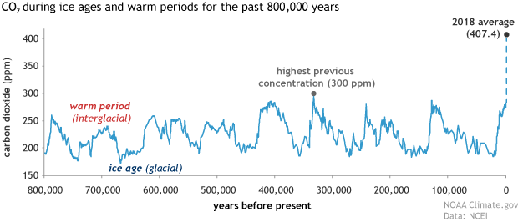

This graph, based on the comparison of atmospheric samples contained in ice cores and more recent direct measurements, provides evidence that atmospheric CO2 has increased since the Industrial Revolution. (Credit: Luthi, D., et al.. 2008; Etheridge, D.M., et al. 2010; Vostok ice core data/J.R. Petit et al.; NOAA Mauna Loa CO2 record.)

The Earth's climate has changed throughout history. Just in the last 650,000 years there have been seven cycles of glacial advance and retreat, with the abrupt end of the last ice age about 11,700 years ago marking the beginning of the modern climate era — and of human civilization. Most of these climate changes are attributed to very small variations in Earth’s orbit that change the amount of solar energy our planet receives.

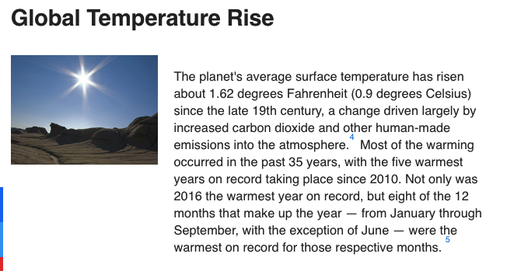

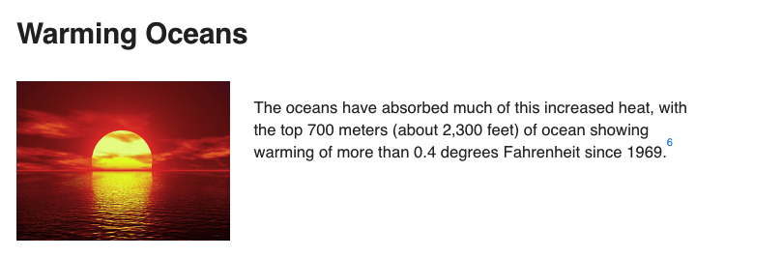

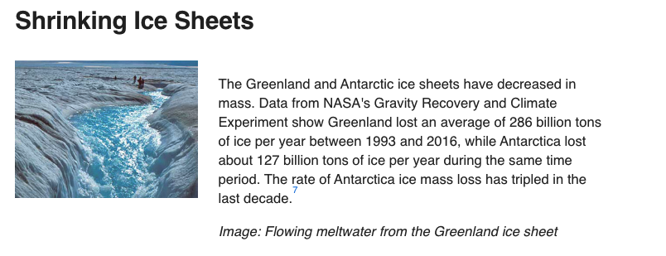

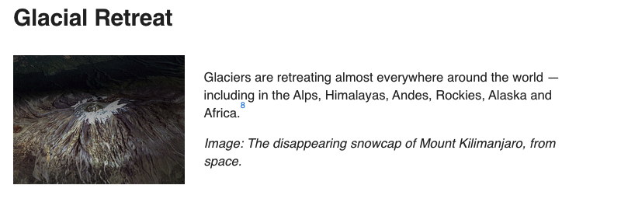

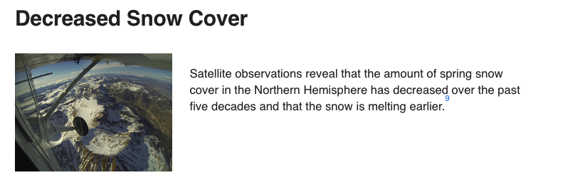

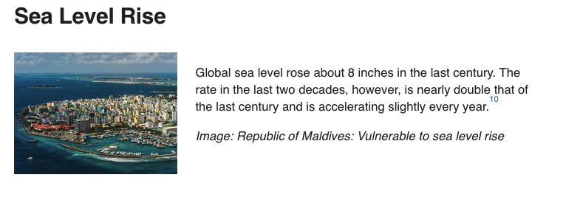

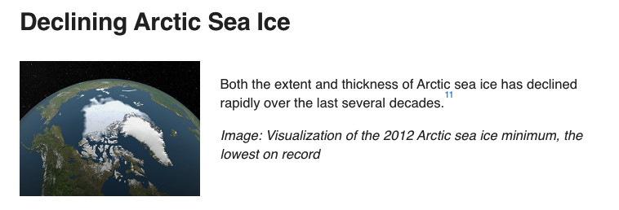

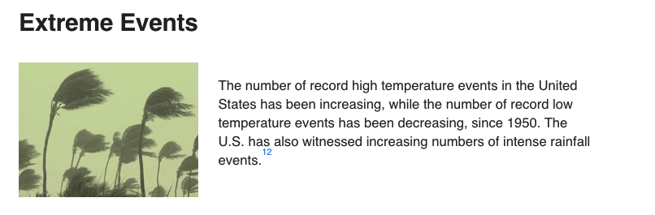

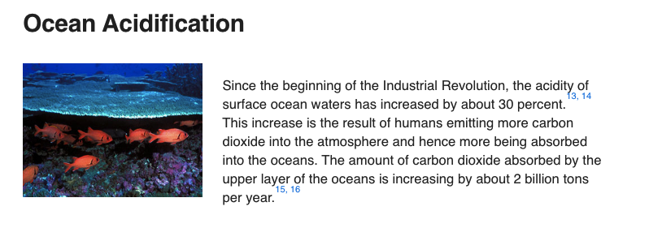

**Activity 3: Climate Refugee Article Analysis**

* Read the article below.
* As you read, please answer the following questions in complete sentences.

1. How do the refugees in this article feel?

1. Describe the cause(s) that led this person/people to be a climate refugee.

**Drought Migrants**

Two Honduran brothers weigh the weather odds – to stay or leave home?

*This story was adapted from heatofthemoment.org and was produced in collaboration with iSeeChange, a community climate and weather journal.*

Noel and Alcaldio Martinez are two brothers in a family of 15. Noel is number 7, Alcaldio number 3. The brothers are close and talk on the phone almost every day. Lately, because of persistent drought in their home country of Honduras, they've been having the same conversation over and over again: whether it's better to leave or better to stay in Honduras. So far they’ve made opposite choices. Alcaldio stayed, Noel left.

I first met Noel Martinez at work in New Orleans, remodeling a basement apartment. He and three other men were working on a day when most people went home early because of flooding. When I asked why the men opted to work in such terrible weather, they told me they don’t rest for this kind of weather. “In Honduras, there isn’t work because there isn’t enough rain,” Noel said. Not enough rain, for a long time now. That’s why he’s here.

Noel and his brother Alcaldio grew up in a tiny town in the Central Honduran state of Yoro, surrounded by big pine tree forests. Every year, people there wait for the May rains to plant their fields and feed their animals. And when the rains do come to Yoro, people say it rains so hard, it rains fish. They post cell phone videos online  to try and prove it really happens.

But for the last four years and counting, it’s been abnormally dry — and not just in Yoro. Across Central America, less rain has been falling later in the season. High temperatures have been breaking records. Staple crops like corn and beans and exports like coffee and bananas have been failing from fungus, pests and drought.

The pattern is precisely what climate change models predict for the region as global temperatures rise. It’s what drove Noel and Alcaldio to make different bets — to cross the border to the U.S. in search of work, or to wait out the weird weather and drought in Honduras.

Being in the U.S. wasn't Noel's first choice. He borrowed from the bank to buy pesticides for his fields, but when the May rains didn’t come, he lost the crops anyway, along with the money. So he sold the farm and moved north to the city to cut palms. But the work didn’t pay enough to support his family, so after five years of deliberating, Noel opted to go even further north to an entirely foreign city.

As Noel crossed the border, Alcaldio stayed back because he still had a job. He was a milkman at a dairy, a job that is supposed to be more stable than farming from one season to the next. But things were tough in Honduras. Another brother, who also stayed, was murdered. “He was a farmer, and they just stole what he had on him and killed him,” Noel said. “All of this leads people to crime, I don’t know, as a way of making easy money.”

Noel got the news while he was still crossing the border and wanted to turn back and go home for the funeral. But his family told him to keep going — both the drought and violence in Yoro were getting worse. The Dry Corridor that spans Honduras, Guatemala and El Salvador in Central America had been quietly expanding its boundaries and pushing rural farmers just like Noel into bankruptcy and starvation. Today, an estimated 3.5 million people  don’t have food and twice that many are out of work.

You’ve probably heard a lot about Central American migrants — children crossing the border alone, families moving in record numbers. You’ve probably also heard people say they are refugees from violence, and they are. But violence and the drought that brought Noel aren’t entirely separate. Because droughts put so many out of work, research tell us climate change undermines security. Desperate people turn to crime, turn on each other, turn to other countries. People who flee weather or drought can't legally claim refugee status. If they are fleeing violence, however, they can — so that's what people list in immigration documents; it's what gets documented. But beneath it all, climate is an invisible but constant force.

Noel moved to New Orleans two and a half years ago hoping for a better life. But these days, he spends most of his time yearning for home. He hasn’t seen his five children or his wife since he got in the car and left them behind three years ago. “You don’t know when you’re going to see them again,” he said. “It’s really hard.”

Noel doesn’t want to live like this, he has plans to go back some day, but it’s hard to make the leap now that everyone's dependent on the money he is making here. This is what Noel keeps telling Alcaldio: supporting the family here, means risking never seeing them again there. Despite hearing all about Noel’s life in New Orleans and how much he misses home life in Honduras — Alcaldio now says he wants to come.

“He’s been asking me non-stop to help him come here,” Noel said. “I told him: Let’s wait. I’m going to see how things are.” Alcaldio isn’t just missing his brother. Last year, the dairy where Alcaldio was working fired everybody. Without rain there’s no pasture, so the cows were starving. The ranch owner had no other option but to sell the cows for meat.

In 2016, things got more dire. Fires raged as controlled agricultural burns got out of control. The smoke kept international flights from landing at the airport. By April, the only work Alcaldio could find was guarding wood in the lumber yards, a job created by extreme heat. It caused Southern bark beetle populations to explode; they devoured all the pine tree forests across Honduras. The only way to stop the beetles is to cut down the trees and use them for lumber.

Growing up, Noel said he always looked up to his confident older brother. But now it’s Alcaldio looking to Noel for confidence as the Honduran heat erodes it. Noel urged him to be patient: Wait. What if the May rains come?

By April, people in Noel and Alcaldio’s hometown had begun to ration water: two hours in the morning, two hours at night. But there was still not enough to fill their tanks. Alcaldio and his neighbors were losing hope. But then something happened that surprised and delighted the town: the May rains came early. “The land got wet and we got happy because it calmed the dust,” Alcaldio said, also speaking in Spanish. “It cleared the smoke in the air. The animals that were sad from thirst and heat, got happy as well.” With three more rains, he said, the jobs everybody lost would start coming back.

But while the rain might have changed Alcaldio’s job prospects, it still hasn’t changed his decision to come to the U.S. The lumber Alcaldio has been guarding had him thinking hard about the future — it came from pine trees that are essential to cooling the region and to longer-term rain patterns. Alcaldio knows his hometown and the difference between today’s weather and tomorrow’s climate. A single storm, this one season’s sigh of relief, can’t erase the longer-term risks of living in an unpredictable climate.

Now the pine trees are gone — thanks to beetles and extreme heat — and Alcaldio worries his hometown is becoming a desert. To survive, Alcaldio says he needs to migrate, just like the animals already have. He says it’s what he needs to do to support his family.

There’s the illusion that a right choice can be made here, one that will make the two brothers happy, make their family happy. But as they eye each other across the border, as much as they can see all the ways the other one got it right, they can also see all the ways the other one got it wrong.

Any choice comes with a cost. Floods one place. Drought another. Loneliness here. Poverty there. As the climate changes, Noel, Alcaldio, and all of us are in a new world of decision risk.

Lastly answer the following questions:

1. Which effects (from Activity 2: "Climate Change: How do we know” Evidence Activity #1-10) are represented in this article?

1. What are 1-2 solutions you can suggest to solve this refugee’s problem?